
Kubernetes observability lab for Ara Institute of canterbury
Project Proposal
Version 0.5

Kabir Singh Thukral
BCIS309 – Work-Integrated Learning Project, NETWORKING INFRASTRUCTURE
Semester 2, 2026
Contents
List of tables ii
List of Figure iii
Proposal Introduction 1
Proposal Project Details 2
Project Name 2
Overview of Industry Client 2
Project Background 2
Overview 2
Current Situation 2
Future Situation 2
Proposal Project Scope 3
Project Goal(s) 3
Industry 3
Student 3
Benefits of Project 3
Industry 3
Student 3
User Stories 4
Expected Deliverables 4
Industry 4
Academic 4
Proposal Stakeholder Management 5
Project Hierarchy Industry Stakeholders 5
Reporting and Meetings 5
Proposal Student Skills 6
General Skills Required 6
ICT-Specific Skills Required Containerisation and Orchestration 6
Skills from Relevant L6 and L7 Courses 7
Approach to Learning New Skills 8
Proposal Project Plan – High Level 9
Phases 9
Burndown Charts 11
Academic 13
Resources/Access Required 13
Detailed Project Plan 14
Proposal Risk Management 16
Risk Table 16
Proposal Quality Assurance 18
Approach 18
Quality Assurance Table 18
Test Plan/Scenarios/Cases – Industry Only 19
Proposal Methodology 20
Overview 20
Literature Review 20
Critique (Pros and Cons) 20
Proposal Professionalism, Sustainability, Inclusive Practice and Te Tiriti o Waitangi 21
Relevant Legislation 23
Privacy/Confidentiality 23
Copyright 23
Patents 23
Relevance of Project Goal to a New Zealand Context 23
Relevance of Principles to Student and Industry 24
Proposal Reflections 24
Approach 24
References 25

List of tables
Table 1 Industry Stakeholders 5
Table 2 Academic Stakeholders 5
Table 3 Project Plan Academic Timetable 10
Table 4 Project Plan Industry Timetable 11
Table 5 Industry Deliverable 14
Table 6 Academic Deliverable 15
Table 7 Risk Table 16
Table 8 Quality Assurance Table 18
Table 9 Test Plan/Scenarios/Case 18
Table 10 Professional Standards Alignment Table 22
Table 11 Te Ao Māori Principles Alignment 24

List of Figure
Figure 1 Industry Sprint Project Plan 9
Figure 2 Timetable 10
Figure 3 Industry Burndown Chart 11

Document Control
Date | Author | Version | Status of Document/Updates Made
23/08/2026 | Kabir Singh Thukral | v0.1 | Document Creation
26/08/2026 | DR Bernard Otinpong | v0.2 | Submitted for feedback
31/08/2026 | Abdul Rehman | V0.3 | Submitted for feedback
31/08/2026 | DR Bernard Otinpong | V0.3 | Submitted for feedback
6/09/2026 | DR Bernard Otinpong | V0.4 | Submitted for feedback
6/09/2026 | Abdul Rehmann | V0.4 | Submitted for feedback
09-09-2026 | DR Bernard Otinpong | V0.5 | Submitted for feedback
09-09-2026 | Abdul Rehman | V0.5 | Submitted for feedback

AI Usage Declaration
This report represents my own original thinking, research, and analysis. The tools that were used for this report is as follows: -
- Microsoft Word and Microsoft Excel – for drafting, formatting, and data analysis.
- Grammarly – for grammar, spelling, and writing style suggestions.
- Claude – used in a limited capacity for minor clarification and refining the wording of certain sections.
AI tools were not used to generate the core content, arguments, or findings of this report. All ideas, analysis, and conclusions are my own.

Proposal Introduction
This report will outline all the important details of the project and the required deliverables. The project's scope will also be described in this report.
A project plan is important for understanding the project, so this will outline its scope of it, deliverables, requirements, and timeline, which will also be signed by the necessary stakeholders who are within the project.
This project proposal has been done with the Networking Team, which is a part of Ara Institute of Canterbury Ltd, which includes an academic supervisor, an industry supervisor and student Kabir Singh Thukral.
The important scoping of the project is as follows
- Project details as investigated.
- Project background and details as investigated
- Project goals and its outcomes
- All the technical requirements which are required for the completion of this project
- Stake holder roles and their responsibility
- Sprint planning, timetables and burndown charts
- Required skills for the project and the approach to new learning
- Quality assurance and testing method to make sure that the required standards are met
- Risk table and strategies used to manage them
- Software and hardware resources which are required for the project
- Skills which I will be using from the level 6 and level 7 courses
- Project scope given by the industry supervisor.
- The methodology of the project and the outline of the project.
- The important standards required, like professionalism, standards, and ethics, must be followed.
- All risks must be kept in mind, and it must be ensured that risk management has been done in the right way.

Proposal Project Details
This will outline the evaluation of a reusable Kubernetes observability lab environment which is designed to help with learning activities for the DSYS601 DevOps course at Ara Institute of Canterbury.

Project Name
Developing Kubernetes Observability Lab for a Networking Course DSYS601

Overview of Industry Client
Ara Institute of Canterbury
Ara Institute of Canterbury is a tertiary education provider in New Zealand. It helps provide education to students across the country in different fields like computing and information technology. In this industry project, the Networking Team is within the Computing Department of the Faculty of Applied Technology. The Networking Team has identified the need to develop reusable observability labs for the course DSYS601, in which there are currently none (Ara institue of Canterbury, 2026).

Project Background

Overview
The Networking course, DSYS601, needs a practical environment for students so that they can have a reusable Kubernetes lab where they can learn Kubernetes monitoring and observability.

Current Situation
Currently, students don’t have a Kubernetes platform or feature on their workstations, which makes it challenging for students to automate and scale, manage containerised applications and resource usage, and practice and monitor the workload, which also leads to failure of the pod and resource usage

Future Situation
Once the project is completed, students in the Networking pathway will have a reusable Kubernetes lab. It will provide practical experience to future DSYS601 students

Proposal Project Scope
This proposal defines the goals, responsibilities, requirements and expected deliverables for the given project.

Project Goal(s)
Developing a reusable Kubernetes lab for the course DSYS601 so that students can practice on it and monitor troubleshooting application running multi node environment.

Industry
Provide the Networking Team with a reusable observability lab for DSYS601 teaching.

Student
Developing skills in Kubernetes, observability, monitoring and troubleshooting

Benefits of Project

Industry
Making a reusable lab environment so that practical learning support can be given to current and future students in the DSYS601 course.

Student
Students will gain more knowledge if they work with other features such as Prometheus, Grafana, monitoring, alerting and troubleshooting. Project Requirements
Requirements that need to be completed for this project include:
- Making a reusable multi-node Kubernetes cluster.
- Making a small multi-service working demo application.
- Monitoring techniques using Prometheus and Grafana.
- Making sure that the lab is reliable to use and gets reset using documented configuration.
- Storage Architecture Research
- Research and compare storage options, which include emptyDir and Persistent Volumes and then recommend the suitable option for the lab.
- Resource Sizing Analysis
- Analyse the host's available CPU, memory and storage capacity against the requirements of the Kubernetes control plane, worker nodes and the Prometheus/Grafana observability stack, and recommend appropriate resource requests and limits for the lab environment.
- All Kubernetes manifests, configuration files and teardown scripts will be held in a GitHub repository with pinned software versions, so the lab can be reliably rebuilt and reproduced by future DSYS601 students.
- Failure Injection and Alerting
- Version Control and Reproducibility
- Create a teardown/reset procedure so that the lab can be removed and rebuilt for future students.

User Stories
- As a DSYS601 student, I need to know how to monitor so that I can understand application and cluster health.
- As a DSYS601 student, I need to know what kind of alerts come up when a system failure happens so that I can identify the problem and then troubleshoot it.
- As a lecturer, I want a reusable Kubernetes lab so that I can teach future students in the DSYS601 course.

Expected Deliverables

Industry
- Kubernetes Cluster suitability report
- Reusable multi-node lab environment
- Host hardware, CPU, and memory sizing recommendation
- Reusable single-host, multi-node Kubernetes lab environment
- Small multi-service demo application
- Prometheus and Grafana observability environment
- Grafana monitoring dashboards
- Alertmanager rules and alert configuration
- Failure-injection testing evidence for CrashLoopBackOff, memory exhaustion, and node pressure
- Teardown and reset procedure

Academic
- Prepared CV and Cover letter
- Interview with potential company
- Weekly summarisation reviews
- Burn-down charts
- Will and any agreement schedules
- Project proposal
- proposal checklist
- project proposal approval form
- Methodology essay
- Halfway project report
- Industry Supervisor halfway assessment
- Academic supervisor halfway assessment
- Final report
- Project poster
- Panel presentation
- Short paper
- Reflection Diary Journal
- Student Photo

Proposal Stakeholder Management
It includes all the stake holders which are involved in this project and explains how communication, reporting, and meetings will flow throughout the project.

Project Hierarchy
Industry Stakeholders
Table 1
Industry Stakeholders
Name | Role | Email
Abdul Rehman | Industry Supervisor | Abdul.Rehman@ara.ac.nz
Kabir Singh Thukral | Student Intern | Kat0870@arastudent.ac.nz

Academic
Table 2
Academic Stakeholders
Name | Role | Email
Dr David Weir | Course Convenor | david.weir@ara.ac.nz
Dr Bernard Otinpong | Academic Supervisor | bernard.otinpong@ara.ac.nz
Phillip Roxborogh | Course Convenor | phillip.roxborogh@ara.ac.nz
Kabir Singh Thukral | Student Intern | kat0870@arastudent.ac.nz

Reporting and Meetings
Meetings will be held in person or via video call.
Industry
1st meeting will be held on Monday
Time: 12 pm – 1 pm
Venue: Ara Institute of Canterbury
Agenda: weekly update and any questions
Attendees: Industry supervisor and student

2nd meeting will be held on Thursday
Time: 12-1
Venue: Ara Institute of Canterbury
Agenda: Weekly update and questions
Attendees: Industry supervisor and student
Academic
BCIS309 Class Attendance
Time: Monday 3 pm – 5 pm and Thursday 1 pm – 3 pm
Attendees: All BCIS309 Students
Wednesday, Academic Supervisor Meeting
Time: 11 am – 12 pm
Venue: Ara Institute of Canterbury

Proposal Student Skills
The skill sets, toolkit requirements and development through the project.

General Skills Required
- Communication Skills
- Problem-solving skills
- Time management
- Teamwork and collaboration
- Research and analytical skills
- Documentation and reporting skills
- Attention to detail
- Scrum meetings
- Sprint meetings

ICT-Specific Skills Required
Containerisation and Orchestration
- Docker creation
- Kubernetes
- Kind/k3s/minikube
- YAML manifest authoring
- Multi-node Kubernetes configuration
Observability Architecture
- Kube-state-metrics
- Node-exporter
- Grafana dashboard creation
- Alert manager configuration
Tooling and Systems
- Linux administration
- Shell scripting
- Git and GitHub
- Troubleshooting and testing

Skills from Relevant L6 and L7 Courses
BCCS283 – Network infrastructure
- Network design
- Network topology
- Container network design
- Pod and Service IP addressing
- Kubernetes DNS and service discovery
- Network configuration
- Troubleshooting
BCCS292 – Switching, Routing and Wireless Essentials
- Static and dynamic routing
- Cluster node connectivity configuration
- Kubernetes Service routing and load balancing
- Network connectivity testing
- Troubleshooting
BCCS295 – Enterprise Networking, Security and Automation
- Enterprise network design
- Advanced routing
- Access control list
- Network security
- WAN concepts
- Network monitoring
- Network automation
NZDC602 – Cryptography
- Encryption and decryption
- Hashing
- Authentication
- Digital certificates
- Public/private keys
- Secure communication
NZDC605 – Ethical Hacking and Testing
- Vulnerability assessment
- Penetration testing concepts
- Network scanning
- Security testing
- Threat identification
- Security reporting
BCIS303 – IT Governance:
- IT risk management
- Governance framework
- Project governance
- Documentation
- Managing ICT-related risks
BCIS207 Enterprise Solutions Deployment
- Using excels
- Methodology learning
- Technical skills

Approach to Learning New Skills
- Using online tutorials like YouTube, Chrome, etc.
- Seeing what the issues are and then troubleshooting in different ways.
- Applying new skills which we learn.
- Learning Docker basics.
- Learning Kubernetes to create a reusable multi-node cluster.
- Learning Prometheus to manage and monitor the lab.
- Learning Grafana to make a dashboard for the application.
- Improving my Linux skills.
- Learning how to perform failure testing using different features and techniques.
- Learning how to use Alertmanager to configure and test alerts for different situations

Proposal Project Plan – High Level
The high-level project plan provides an overview of how the project will be managed from the first to the final stage of the project. The progress will be supervised by the allocated academic and industry supervisors to make sure that all kinds of requirements and deliverables are completed and achieved.

Phases
Academic Six-Phase Project Plan
The academic plan will consist of 6 different phases, which are initiation, definition, design, development, implementation, and follow-up. My first target would be to gather the requirements of the project and then start designing the project accordingly.

Figure 1
Industry Sprint Project Plan
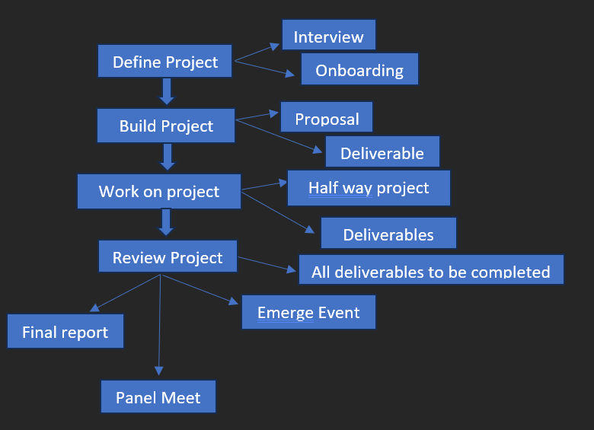
In this, I am going to use a sprint-based approach. Each sprint is going to focus on a specific part of the network project, and this strategy will help the project to come to an end. This sprint will cover design, configuration, testing, and final review. Each week, the progress made on the project will be discussed with the industry supervisor (ND, 2026).

Figure 2
Timetable
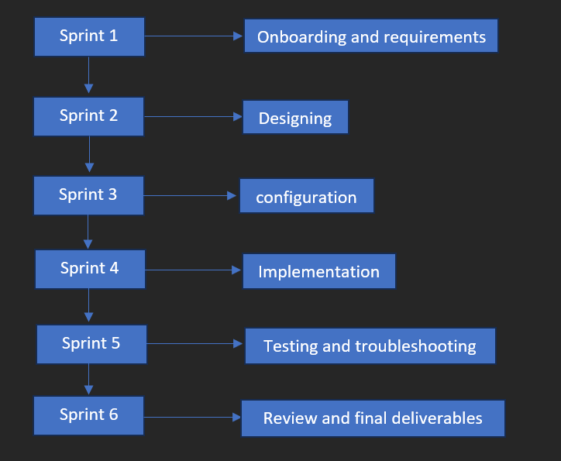
Table 3
Project Plan Academic Timetable
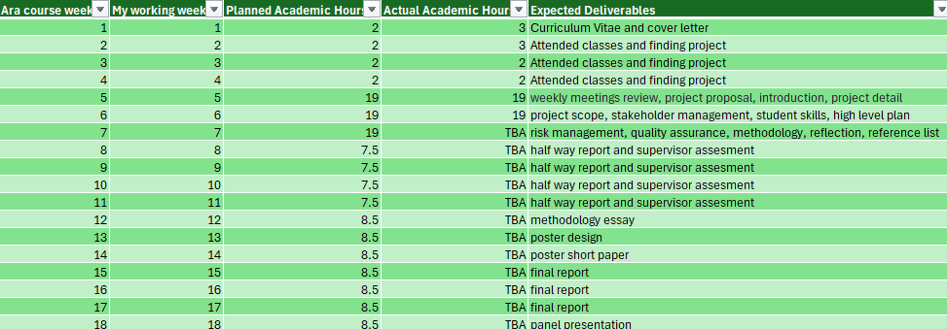

Table 4
Project Plan Industry Timetable
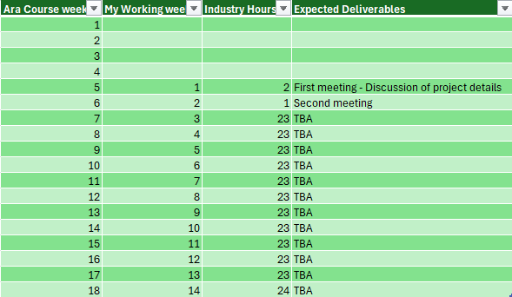

Burndown Charts
Figure 3
Industry Burndown Charts

This burndown chart shows the progress of my industry project. I started with 300 total hours. The planned line shows how the remaining hours should reduce each week, while the actual line shows my real progress. At the moment, my actual remaining hours are slightly higher than planned, which means I am a little behind schedule. I will keep updating the chart each week to track my progress and make sure I complete the required hours on time (nd, 2026).

Academic

Figure 4
Academic Burndown Chart
This academic burndown chart shows my progress for the academic part of the project. I started with 154 planned hours and have completed 66 hours so far, leaving 88 hours remaining. My actual progress is slightly behind the planned schedule, but I will continue updating the chart each week as I complete more academic work and deliverables (nd, 2026)

Resources/Access Required
Software
1. Microsoft Visio / Draw.io
2. Microsoft Word
3. Microsoft Excel
4. Web browser
5. Kubernetes
6. Docker
7. Kubectl
8. Node Eporter
9. Visual studio code
10. Git
11. Git Hub
12. Powershell/Terminal
13. Windows
14. Linux operating system
Hardware
1. Internet connection
2. Laptop
3. Access to ARA networking lab and classroom
4. Virtual Machines
5. Physical Server, if required
6. Storage / Backup Drive
7. Virtualisation-enabled system
8. Cloud or network storage, if required

Detailed Project Plan
Organisation – Ara Institute of Canterbury
Project Title – Kubernetes Observability Lab
Industry Supervisor – Abdul Rehman

Table 5
Industry Deliverable
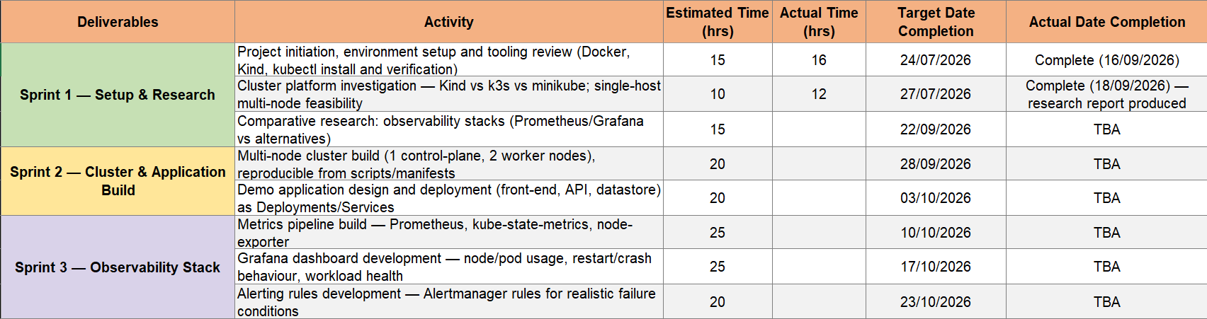
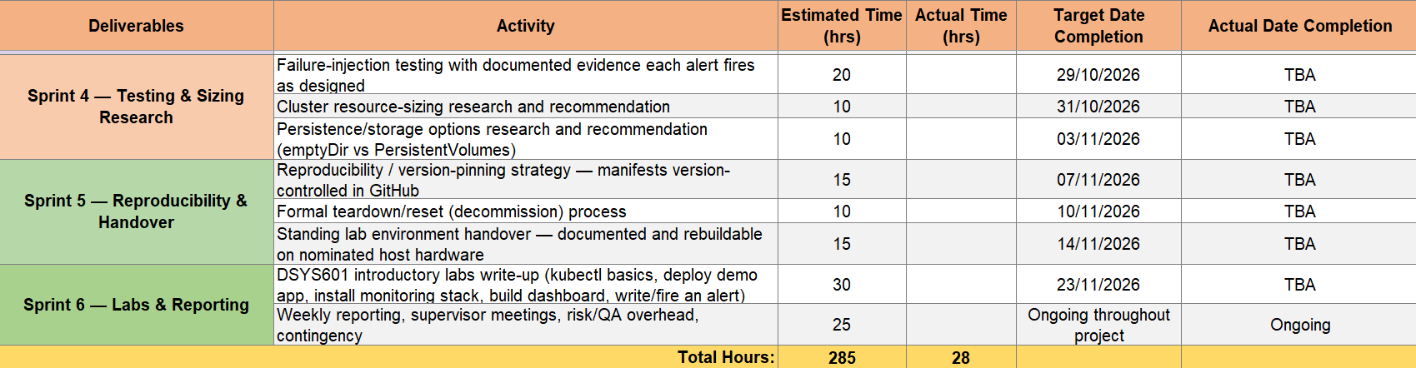
Table 6
Academic Deliverable
Deliverables | Activity | Estimated Time (hrs) | Actual Time (hrs) | Actual Date Completion
Curriculum Vitea and Cover Letter | Creating Cv and Cover Letter | 2 | 3 | 23/07/2026
WIL and Confidentiality Agreement | Signed by people who are involved in project | 2 | 3 | TBA
Weekly Academic Supervisor Meeting | Review weekly progress report, risk assessment,  burndown chart | 10 | TBA | TBA
Project Proposal | Project Details | 2 | 3 | TBA
Project Proposal | Project Scope | 3 | 4 | TBA
Project Proposal | Stakeholder Management | 3 | 3 | TBA
Project Proposal | Student Required Skills | 3 | 4 | TBA
Project Proposal | Project Plan | 4 | 4 | TBA
Project Proposal | Burndown Chart | 4 | 4 | TBA
Project Proposal | Risk Management | 5 | 3 | TBA
Project Proposal | Quality Assurance | 4 | 5 | TBA
Project Proposal | Methodology | 3 | 5 | TBA
Project Proposal | Professionalism | 3 | 3 | TBA
Project Proposal | Sustainability, Inclusive Practice, and Te Tiriti o  Waitangi | 4 | 3 | TBA
Project Proposal | Reflections | 3 | 3 | TBA
Project Proposal | Reference | 2 | 3 | TBA
Project Proposal | Appendices | 2 | 2 | TBA
Project Proposal Checklist | Checking requirements needed for checklist | 1 |  | TBA
Project Proposal Sign off | Follows Ara's proposal sign off document | 1 |  | TBA
Halfway Report | Progress Updates, Reflection, What went well, What  did not go well, Improvements | 30 |  | TBA
Methodology Essay | 3,000 words that covers the topic listed in marking  guide. This covers the Agile and Scrum methodology | 15 |  | TBA
Final Report Document | Final Reflections and Self Evaluation | 20 |  | TBA
Final Report Document | Review final report document | 3 |  | TBA
Final Report Document | Ask for feedback | 2 |  | TBA
Short Paper | Includes introduction, title, author, methodology,  process, conclusions, and reflections | 2 |  | TBA
Poster | Poster is A1 format. Includes Introduction, title,  author, methodology, process, conclusions, and reflections | 3 |  | TBA
Short Bio | Professional written of backgrounds and achievements | 2 |  | TBA
Panel Presentation | Creating powerpoint presentation slides | 4 |  | TBA
Panel Presentation | Practice for presentation | 7 |  | TBA
Panel Presentation | Presentation | 1 |  | TBA
 | Total Hours: | 150 | 55

Proposal Risk Management
This section will focus on any risks I may face during the project's development.
Approach
This section identifies the main risks that may affect my project, including technical problems, communication issues, time management, illness, cluster failure, resource limitations and false alerts.
I will use a risk register to track each risk. For every risk, I have considered its probability, impact and exposure before and after mitigation. I have also included mitigation actions, contingency plans and triggers so I know what action to take if a risk occurs.
The risk table will be reviewed regularly throughout the project and updated if any new risks are identified. Important risks will also be discussed with my academic and industry supervisors (n.d, 2026).

Table 7

Risk Table
# | Risk Statement |  | Pre-Mitigation |  |  | Mitigation | Post-Mitigation |  |  | Contingency | Triggers
# | Condition | Consequence | Probability (1%-99%) | Impact (1-10) | Exposure | Mitigation | Probability (1%-99%) | Impact (1-10) | Exposure | Contingency | Triggers
1 | Lack of Technical Skills | Difficulty configuring and troubleshooting the Kubernetes cluster and observability tools | 20% | 8 | 1.6 | Use documentation, tutorials, testing, and seek guidance from the Industry Supervisor when required | 15% | 7 | 1.05 | Review documentation and seek supervisor support | Unable to complete configuration or repeated technical errors
2 | Struggle to Adapt to Company Workflow | Tasks may take longer and project progress may be affected | 35% | 8 | 2.8 | Attend regular meetings, follow agreed workflows, and use supervisor feedback | 25% | 7 | 1.75 | Discuss workflow problems with the supervisor and adjust the work plan | Missed tasks, difficulty following processes, or repeated corrections
3 | Lack of Communication | Requirements may be misunderstood, resulting in rework or project delays | 30% | 7 | 2.1 | Maintain regular communication and weekly meetings with supervisors | 20% | 6 | 1.2 | Arrange an additional meeting to clarify requirements | Missed meetings, unclear requirements, or delayed responses
4 | Poor Time Management | Project milestones and deliverables may be delayed | 30% | 6 | 1.8 | Follow the project timetable, prioritise tasks, and review progress weekly | 20% | 4 | 0.8 | Reprioritise remaining tasks and discuss delays with the supervisor | Missed deadlines or tasks taking longer than planned
5 | Illness | Project work may be interrupted, resulting in delays | 15% | 5 | 0.75 | Maintain documentation and Git commits so work can continue after absence | 10% | 5 | 0.5 | Inform supervisors and revise the project schedule if required | Unable to attend meetings or complete planned project hours
6 | Single-Host Cluster Failure | Control-plane and worker nodes may fail simultaneously, making the lab unavailable | 30% | 9 | 2.7 | Maintain fully scripted cluster builds in Git | 10% | 6 | 0.6 | Rebuild the cluster using scripts and configurations stored in Git | Host crash, nodes become NotReady, or cluster becomes inaccessible
7 | Host Resource Exhaustion | Observability stack may exceed CPU or memory limits, causing Pods or services to fail | 40% | 8 | 3.2 | Enforce explicit resource requests and limits on all deployed workloads | 15% | 5 | 0.75 | Reduce workload usage, restart affected Pods, and adjust resource allocations
8 | False Positive Alerts | Alerts may trigger during normal metric fluctuations and create unnecessary investigation | 35% | 6 | 2.1 | Perform failure-injection baseline testing to calibrate alerting thresholds | 15% | 4 | 0.6 | Review and adjust Prometheus/Alertmanager thresholds and rules | Alert fires when there is no genuine failure condition
9 |  |  | 0% | 0 | 0 |  | 0% | 0 | 0
10 |  |  | 0% | 0 | 0 |  | 0% | 0 | 0

Proposal Quality Assurance
This section will make sure that the quality of the project is checked and maintained regularly.

Approach
The checking and testing of the project will be an ongoing process throughout the project so that the quality is maintained. When I do the project, I will make sure everything is secure and properly completed. Will be taking regular feedback from industry and academic supervisors to ensure nothing is going wrong.
Definition of done is when the given task is completed, working, secure, and approved by academic and industry supervisors.

Quality Assurance Table

Table 8
Industry Quality Assurance Table
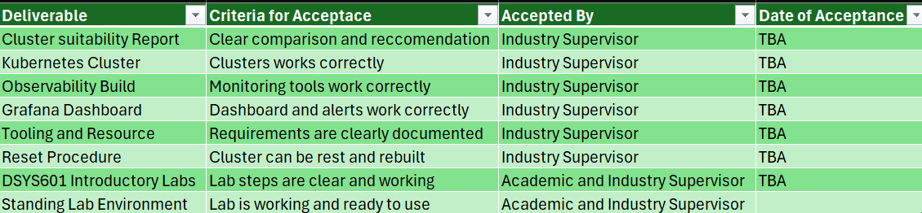

Table 9
Academic Quality Assurance Table
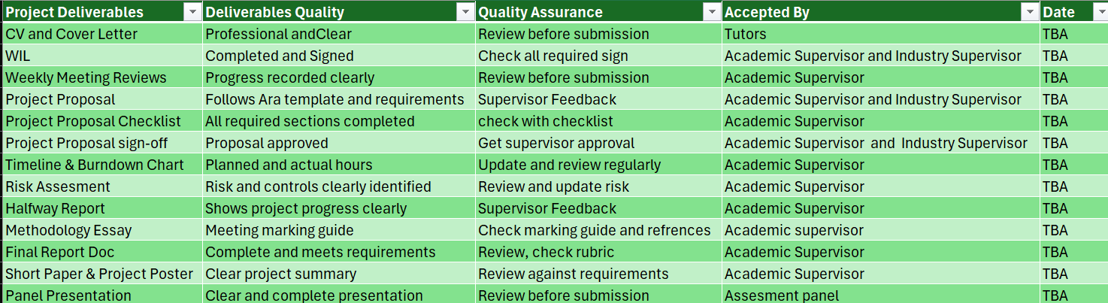

Test Plan/Scenarios/Cases – Industry Only
The testing will make sure that the Kubernetes lab works correctly. I will test the cluster, demo application, Prometheus monitoring, Grafana dashboards and alerts. I will also create failure situations, such as pod crashes and resource pressure, to check if the system detects the problem and sends the correct alerts. Finally, I will test the teardown and rebuild process to make sure the lab can be rebuilt successfully.

Proposal Methodology
This section outlines all three methodologies that I have used in my project to make Kubernetes observability lab. Agile approach that will be supported by the Scrum framework, is used in different stages of this project, and a testing methodology is used to make sure and verify the functionality and reliability of the project.

Overview
The main methodologies and frameworks that have been used are as follows:-
- Agile Methodology
- Scrum Framework
- Testing and Verification Methodology

Literature Review
Kubernetes Observability Lab will be made in different stages rather than being completed in one go, due to which Agile methodology has been chosen. The project is going to have different types of technical activities, like configuring the implementation, deploying Kubernetes components, testing the lab environment, and, if it requires any kind of improvement or if there are any kind of failures, then fixing them. Agile Manifesto encourages the team to work at a good pace and deliver all the requirements in a working environment (Gurnov, 2026).
Scrum basically means dividing your work into different smaller parts, which are called sprints. Every sprint includes different things, like the task which are planned and the task which are completed, so that we can check if it is done or not before moving to the next part. It makes it easier to see our progress on the project and then fix any problems. Kubernetes Observability lab will be done with the help of Scrum, so that the project can be done step by step and progress can be noted (Schwaber, 2026).
In this project, I am also going to use a testing framework, as it is going to make sure that the work is done correctly and gives the expected results. It also helps to find problems or errors so that they can be fixed before the project is completed. Any problems found during the project and testing will be fixed and tested again (Khan, 2026).

Critique (Pros and Cons)
Advantages of using Agile Methodology, Scrum Framework, Testing Methodology
- Flexibility
- Early identification of problems
- Continuous improvement
- Manageable workload

Disadvantages of using Agile Methodology, Scrum Framework, Testing Methodology
- Training and skills required
- Difficulty in scalability
- Potential for Scope creep

Proposal Professionalism, Sustainability, Inclusive Practice and Te Tiriti o Waitangi
This section tells us how things are going to work professionally, sustainably, and with inclusive practice throughout the project, while keeping the values and principles in mind.
Industry Values/Principles
As I am going to work with Ara Institute of Canterbury, I will be doing the work professionally, reliably, and responsibly. I will respect different cultures and ideas, and work inclusively with my supervisors and others and follow Ara policies and guidelines. I will be using resources efficiently so that I can create a reusable Kubernetes lab so that students can use it for future labs in the DSYS601 course (Nd, 2026).

Table 10
Professional Standards Alignment Table
Standard | Alignment with Industry Values | My Approach to Meeting It
Reliability & Accountability | Responsible and dependable work | Completing the task on time
Communication | Respectful communication | Regular updates and asking questions if there are any
Attitude | Positive and professional behaviour | Stay respectful and accept feedback
Teamwork | Working with others if required | Communication with supervisors and support others
Motivation | Commitment to completing the project | Staying focused
Open to Learning | Continuous learning and improvement | Learning new tools and supervisor feedback
Professional Ethics | Honest and professional | Following ARA guidelines

Relevant Legislation
In this project, I am going to follow all the relevant New Zealand privacy and copyright laws that are required for the project. I am going to make sure that all the project information, software and resources are used responsibly and according to the ARA guidelines.

Privacy/Confidentiality
All the confidential information related to ARA will be kept secure and confidential and will only be used for the project. No personal or sensitive information will be shared without permission (Nd, 2026).

Copyright
I will comply with copyright by using correct referencing for any kind of external code, images, documents, or any other resource that I may use in my building of the project. Open–source Kubernetes and monitoring tools will be used according to their licence requirements (Nd, 2026).

Patents
I am not going to use any kind of new patented project, so I will make sure that any kind of resources, technologies and tools used are subject to the licence and legal requirements (Nd, 2026).

Relevance of Project Goal to a New Zealand Context
This project will create a reusable Kubernetes observability lab for DSYS601 students at Ara. It will support practical learning in cloud, Kubernetes, monitoring, and DevOps technologies and help students develop skills that are relevant to the New Zealand IT industry.

Relevance of Principles to Student and Industry
Table 11
Te Ao Māori Principles Alignment
Principle | Meaning | Application in This Project
Kaitiakitanga (Guardianship) | Responsible use of resources | Using the computing resources and making a reusable Kubernetes lab for future DSYS601 students (Moorfield, 2026).
Rangatiratanga (Self-determination) | Responsibility for my work | Managing my project tasks, testing the system and taking responsibility for the work (Moorfield, 2026).
Whanaungatanga (Relationships & Connections) | Making positive relationship | Working closely with the academic and industry supervisor and using their feedback to improve my work (Moorfield, 2026).
Mana Reo (Language & Communication) | Respectful communication | Using clear and respectful language in meetings and creating the DSYS601 lab (Moorfield, 2026).

Proposal Reflections
This section outlines the lessons that I have learned and my approach while doing the project.

Approach
Throughout the project, I will carry out reviews to evaluate what went well, what did not, and how to improve in the future. Reflections can be done through several approaches such as peer reviews, regular meetings, and retrospectives. This is designed to promote honest communication. Using notes as part of my project approach involves documenting my progress, thoughts, and ideas throughout the project’s duration. This allows me to review my progress and identify areas of improvement.

References

References
Ara institue of Canterbury. (2026, 09 18). Retrieved from Ara Institue of Canterbury : https://www.ara.ac.nz/?gad_source=1&gad_campaignid=23335893781&gbraid=0AAAAACZYqb4ALYxG5xvJzuzok2EOEvTlt&gclid=CjwKCAjwn67VBhBnEiwAXUIN1cdMWgM4mDN3W6ZQHIj2ntVjSuyxEX0NN1pLGXoomJt3deB5G4vC_BoCxCsQAvD_BwE
Gurnov, A. (2026, march 30). How Agile Software Development Works . Retrieved from wrike.com: https://www.wrike.com/project-management-guide/faq/how-agile-software-development-works/
Khan, M. K. (2026, June 17). What os Software Test Methodology . Retrieved from BrowserStack.com: https://www.browserstack.com/guide/software-testing-methodologies
Moorfield, J. C. (2026, 09 18). Te Aka. Retrieved from maoridictonary: https://maoridictionary.co.nz/search?keywords=kaitiaki
n.d. (2026, 09 18). ara institute of canterbury . Retrieved from Ara Institute of Canterbury : https://moodle.ara.ac.nz/course/view.php?id=15875&section=6#tabs-tree-start
ND. (2026, 09 18). Ara Institue of Canterbury. Retrieved from Ara Institute of Canterbury : https://moodle.ara.ac.nz/course/view.php?id=15875&section=4#tabs-tree-start
nd. (2026, 09 18). ara institute of canterbury . Retrieved from Ara Institute of Canterbury : https://moodle.ara.ac.nz/course/view.php?id=15875&section=3#tabs-tree-start
Nd. (2026, 09 18). ara institute of canterbury . Retrieved from Ara Institute of canterbury : https://www.ara.ac.nz/about-us/
Schwaber, K. (2026, january 15). What is scrum? Retrieved from Scrum.org: https://www.scrum.org/resources/what-scrum-module

